In bootloader mode, STM32 runs at 24Mhz using PLL
Therefore, we work our way into glitching the STM32 by decreasing the frequency.

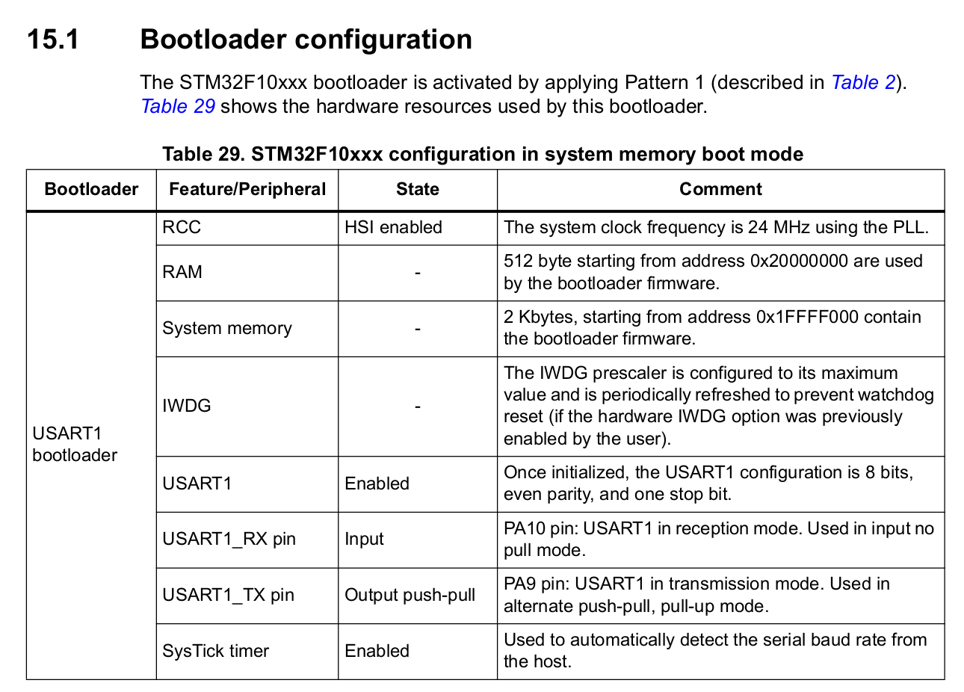

32Mhz
Glitch Duration has an increased effective range: 220ns to 260ns
However, the glitch duration of 240ns 260ns, cause high rates of crashes. Nonetheless, successful glitching was still seen.

260ns:
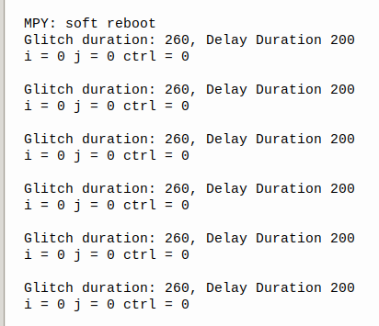

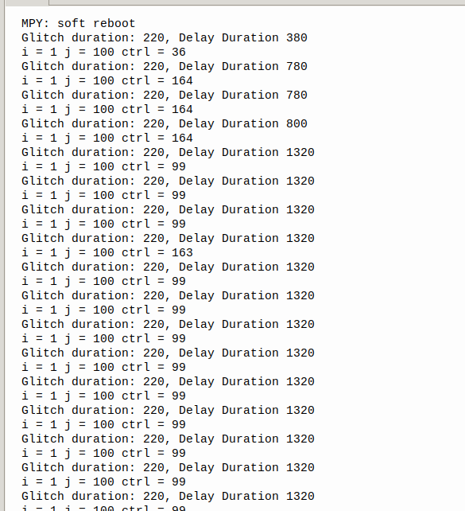
220ns:
- More reliable, better results

24Mhz

3 sets of tests were applied:
- 100 iterations
- 5 iterations + if statement
- if statement only

100 iterations:
Effective glitch range: 210ns to 230ns
- 230ns had very frequent crashes
- 220ns had less crash but also has less glitches
- 210ns has almost no glitch but also does not crash

230ns:
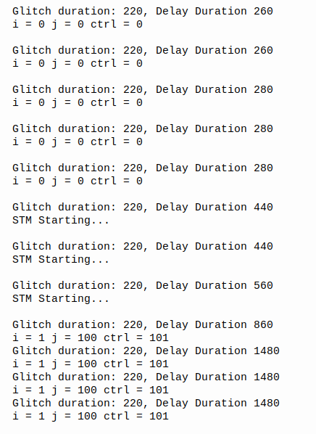

220ns:
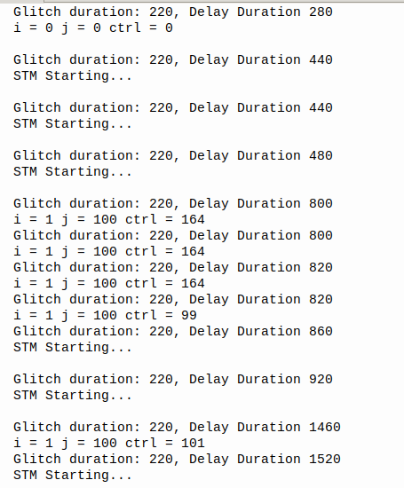

210ns:

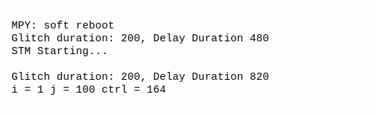

5 iterations with if statement:

Effective range: 210ns to 260ns, with timings of >=230ns being unstable

260ns:
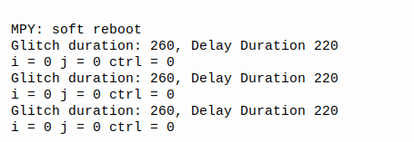

220ns (glitch):
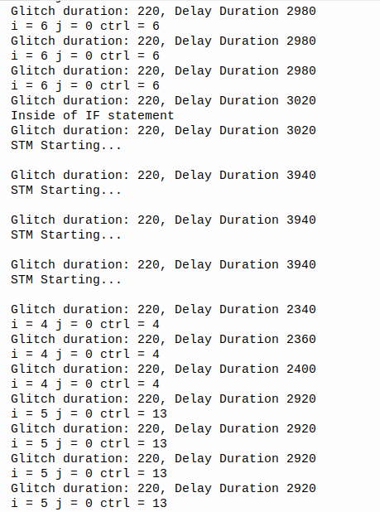

220ns (glitch into if statement):

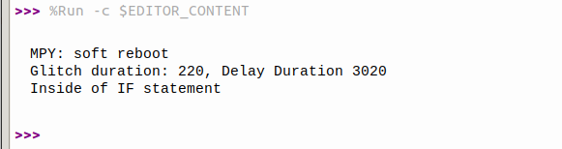

if statement only:

Effective range: 210ns to 220ns

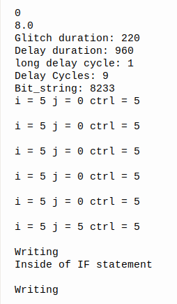

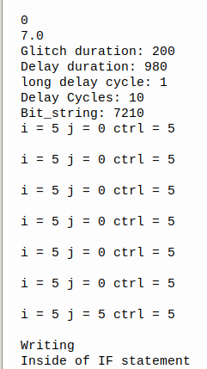

Observations:
- Reliable glitch duration is always approximately 200ns to 230ns, with 210ns and 220ns being the most optimal, regardless of the operating frequency.

Glitching bootloader mode:
- Using the STM32CubeProgrammer, set the RDP.
- Verified that memory can no longer be read using moserial

Naiive Approach:

Manually toggle a pin to simulate rising and falling edge.

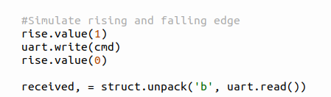

Issues:
- Timing was too long
- Too large an area to search effectively

Need to find a way to reduce the search area.
UART:
Source: https://www.analog.com/en/resources/analog-dialogue/articles/uart-a-hardware-communication-protocol.html

When transmitting data via UART, it will follow the above protocol.

According to the documentation, STM32 will always send a NACK if RDP is set.

Possible to just continually send the command to Read Memory over UART and check the received message.
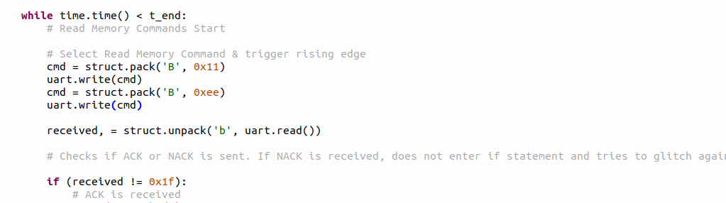

Updated sketch of circuit
Waveform:
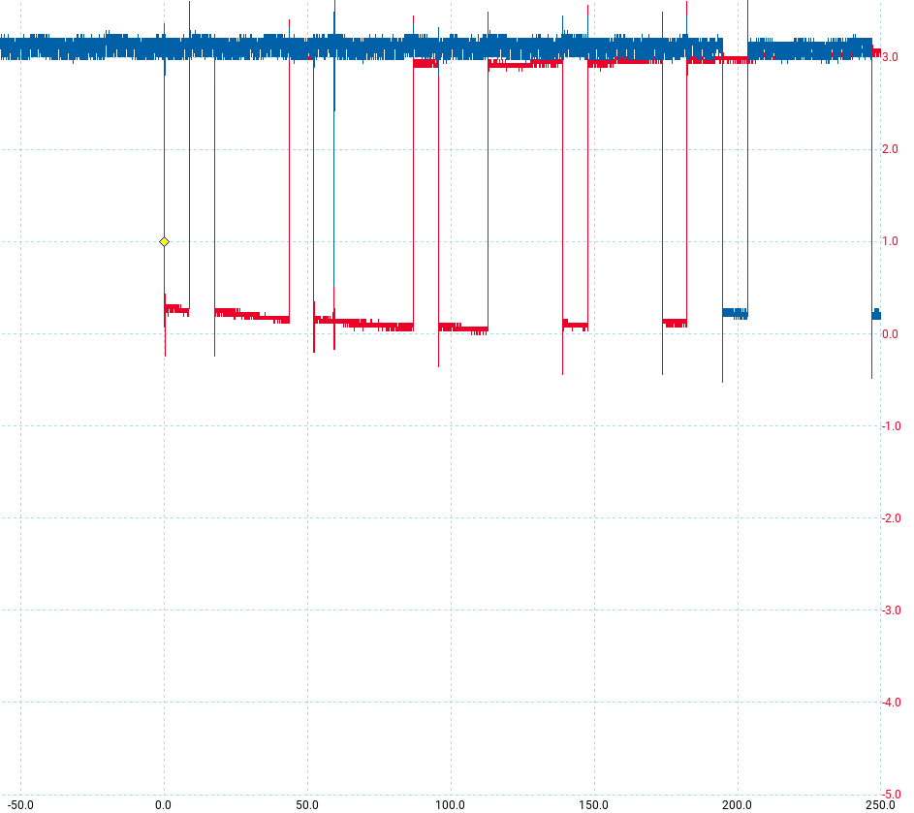

Red Arrow points to the start bit
sent by the Pico to STM.

Blue Arrow points to the start bit
sent by the STM to Pico

Therefore, we can deduce the area to glitch is approximately:
The time between the stop bit of
Pico and start bit of STM

Small change to PIO code to account for the rising edges
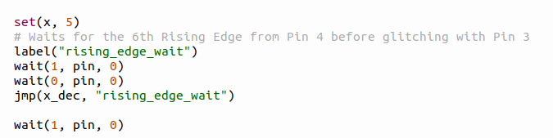

Glitch waveform:
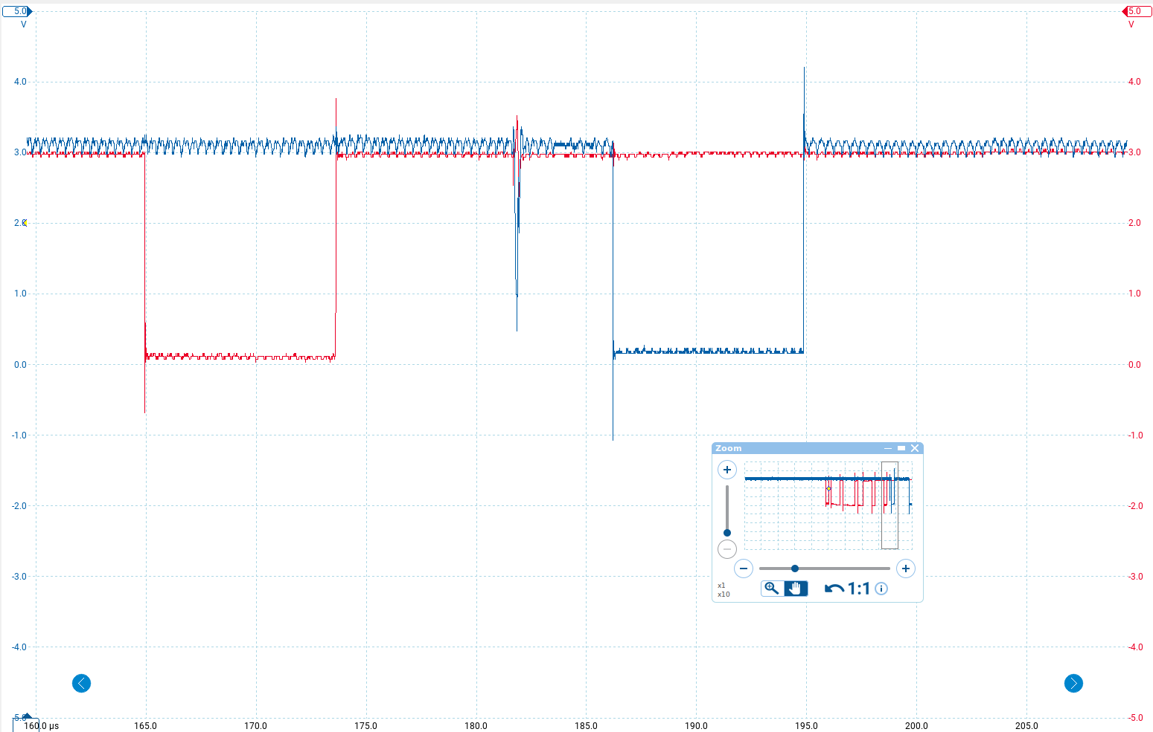

Tried to glitch this area however:
- No glitch results for glitch duration of 200ns.

- For glitch durations of 210ns and 220ns:
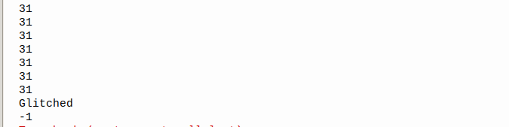
-1 would sometimes be returned during execution. NO successful glitches were made yet

- For glitch durations of 230ns and above:

-1 will be returned very frequently, indicating too long of a glitch duration.

Tried to vary both glitch and delay durations but was unsuccessful in skipping the instruction.
- Could try to wire warp the tx rx wires but not sure about its efficacy
- 3v3 of STM32 must be connected to MOSFET’s output

